COMMUNITY UNITED METHODIST CHURCH
301 CHESTNUT STREET – ROSELLE PARK, NJ 07204
OFFICE: (908) 245-2237+1
- - - - - - - - - - - - - - - - - - - - - - - - - - - - - - - - - - - - - - - - - - -
Rev. Jisu Ahn
PASTOR’S CELL NUMBER: (862) 217-9499
OFFICE HOURS TUES- FRI 10-2PM
* * *
December 7, 2025

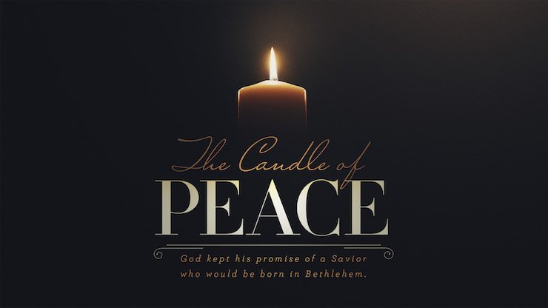

Mission Statement
The Mission of Community United Methodist Church is to be a witness of Jesus Christ for the common good of all peoples by providing Hope and Love to everyone.

Vision Statement
Community United Methodist Church is a place where everyone is welcome to come together to experience and share God’s presence in accepting, caring, nurturing, witnessing, and serving one another and the entire community
December 7, 2025 SECOND SUNDAY OF ADVENT 11:00 AM

~ ~ ~ ~ ~ ~ ~ ~ ~ ~ ~ ~ ~ ~ ~ ~ ~ ~ ~ ~ ~ ~ ~ ~ ~ ~ ~ ~ ~ ~ ~ ~ ~ ~ ~ ~ ~ ~ ~ ~ ~ ~ ~ ~ ~ ~ ~ ~ ~ ~ ~ ~ ~ ~ ~ ~ ~
*Please Stand (If you are able)
GATHERING IN GOD’S PRESENCE

PRELUDE Jeff Manno Organist

WELCOME, GREETINGS AND ANNOUNCEMENTS

SILENT PRAISE AND REFLECTION

PRAISE TEAM “Thou Didst Leave Thy Throne” TFWS 2100

LIGHTING THE ADVENT WREATH The Berry Family
Candle of Peace
Reader 1: On this second Sunday of Advent, we listen to the voice crying out in the wilderness: “Prepare the way of the Lord, make his paths straight.” John the Baptist reminds us that true peace begins with turning our hearts back to God. Today, as we gather in worship, we open ourselves to the peace that Christ alone can give.
Reader 2: In a world filled with conflict, noise, and uncertainty, the peace of Christ comes as a gentle, steady light—clearing the path, calming our fears, and guiding our steps. This peace does not depend on our circumstances; it is a gift from God, offered to all who seek Him with honest and open hearts.
Reader 3: As we light the Candle of Peace, we remember that God calls us to be peacemakers—people whose words bring healing, whose actions build bridges, and whose presence brings calm to troubled places. May this candle remind us that peace is not only something we receive but something we are called to share.
(Light the second candle.)
Reader 1: Let us pray. Gracious and holy God, as we light this Candle of Peace, fill us with the peace that surpasses all understanding. Remove the barriers that keep us from your presence, and straighten the paths of our hearts. Make us instruments of your peace—in our families, our community, and our world. May this light guide us toward the coming of Christ, our Prince of Peace. We pray in His name. Amen.

*CALL TO WORSHIP
Liturgist: A voice cries out in the wilderness, “Prepare the way of the Lord!”
All: We come to make space in our hearts for the One who brings peace.
Liturgist: In a world filled with noise and trouble, God invites us to walk a path made straight with hope and healing.
All: We long for the peace only Christ can give—peace for our hearts, our homes, and our world.
Liturgist: So let us gather with open spirits, ready to receive God’s calming presence.
All: We welcome the Prince of Peace. Come, Lord Jesus, come. Amen.

*GATHERING HYMN “Praise To The Lord The Almighty” UMH #139
OPENING PRAYER
Holy God, in this season of waiting, we gather longing for your peace. Quiet our hearts, clear our minds, and prepare the way within us for your presence. May your Spirit guide us as we worship you with hope and trust. In the name of Christ, our Peace. Amen.
PASSING OF PEACE
JOYFUL NOISE COLLECTION Casano Center Food Pantry
CHOIR ANTHEM “Tell Me Which Way To Bethlehem” Sanctuary Choir

PROCLAIMING THE WORD OF GOD

READING OF THE SCRIPTURE LESSONS
Scripture Reading Luke 3:1–6 Bruce Harms

*REFLECTION HYMN "Hail To The Lord’s Anointed” UMH # 218

MEDITATION Advent Sermon Series Pastor Jisu Ahn
WEEK 2: “The Voice of PEACE”
OFFERTORY
*OFFERTORY HYMN “Give Thanks” TFWS #2036
*DEDICATION OF THE OFFERING
God of peace, receive these gifts and use them to bring healing, hope, and compassion into our world. Make us faithful stewards of your love. Amen.

THE OFFERING OF JOYS AND CONCERNS
PASTORAL PRAYER/ THE LORD’S PRAYER

GOING FORTH TO SERVE THE WORD OF GOD

*CLOSING HYMN “Lift Up Your Heads Ye Mighty Gates” UMH #213
*BLESSING
RESPONSE “Emmanuel, Emmanuel” UMH # 204

POSTLUDE Jeff Manno, Organist

CARRYING CHRIST'S LIGHT INTO THE WORLD
Worshiping God as a “gathered church” has ended, but our life and witness, as a “dispersed church” is about to begin. The light of Christ received today, is the light we bring with us to the world

LECTIONARY READING FOR TODAY
Old Testament: Isaiah 11: 1-10
Psalm: Psalm 72: 1-7, 18-19
New Testament: Luke 3: 1-6
Gospel: Matthew 3: 1-12
~ ~ ~ ~ ~ ~ ~ ~ ~ ~ ~ ~ ~ ~ ~ ~ ~ ~ ~ ~ ~ ~ ~ ~ ~ ~ ~ ~ ~ ~ ~ ~ ~ ~ ~ ~ ~ ~ ~ ~ ~ ~ ~ ~ ~ ~ ~ ~ ~ ~

CUMC Website: roselleparkcumc.org E-mail: cumcrosellepark@gmail.com
COMMUNITY PRESCHOOL Phone: (908) 245-8651 Website: www.rpcommunitypreschool.com

CUMC Upcoming Activities and Events
Save the Date!
Wed Dec 10 Wed night gathering – Bible Study 7:00PM RH
Sat Dec 13 Mens Club Sunrise Diner RP 9:15AM
Sun Dec 14 Worship Service 11:00AM Sanctuary
Wed Dec 17 Wed night gathering – Bible Study 7:00PM RH
Sun Dec 21 Worship Service 11:00AM Sanctuary
Wed Dec 24 Christmas Eve Candle Light Service 7:00PM Sanctuary
Fellowship in Reeves Hall After Service
Sun Dec 28 Worship Service 11:00AM Sanctuary


In our prayers this week:

Wands Family Pinky Burgos Linda Demas Martha Farris
Janet Gallagher Alix (Kessler) Grigal Tommy Grigal Elka Harms John Karathanos Linda Mitola Bob Morgan Donna Petrosky Barbara Powers Nancy Rineer Cindy Shilling Father John Spino Nick and Ruth Sottos
- Stephenson Family Ruth Thomas Linda Trout Evonne Tyree Carol Wilson
- Roger William Elizabeth Woodruff Milt Woodruff Margie Depko Marcus
- Juanita Adames Donna Hutchins & Family Diane Kurz Kevin Murphy
- All those dealing with Mental Health Issues
- Victims Worldwide of Natural Disasters

NURSING HOMES & REHABILITATION FACILITIES
Mary and Neal Commerford



12/1 Lavender McCaffrey

12/6 Nick Sottos

12/7 Janet Gallagher

12/24 Holly VanBuskirk

12/29 Betty Woodruff


Support HEIFER....Buy an Animal
What a Great Christmas Gift!

The tradition continues...... CUMC has supported Heifer International for many years. We are pleased to continue our partnership this Christmas season. Since 1944, Heifer has helped more than 7 million families in the United States and around the world to improve their quality of life and move toward greater self-reliance by providing animals both large and small. They have shown that there is no better way to help a family escape poverty and hunger than to provide them with a means of supporting themselves. When you support Heifer, you will be helping to give a family a wonderful gift that will last.

Visit our table in Reeves Hall through December 21st and purchase an animal or two. Please give generously to Heifer and help lift families out of poverty to health and hope.

