COMMUNITY UNITED METHODIST CHURCH
301 CHESTNUT STREET – ROSELLE PARK, NJ 07204
OFFICE: (908) 245-2237+1
- - - - - - - - - - - - - - - - - - - - - - - - - - - - - - - - - - - - - - - - - - -
Rev. Jisu Ahn
PASTOR’S CELL NUMBER: (862) 217-9499
OFFICE HOURS TUES- FRI 10-4PM
* * *
May 5, 2024

Mission Statement
The Mission of Community United Methodist Church is to be a witness of Jesus Christ for the common good of all peoples by providing Hope and Love to everyone.

Vision Statement
Community United Methodist Church is a place where everyone is welcome to come together to experience and share God’s presence in accepting, caring, nurturing, witnessing, and serving one another and the entire community
May 5, 2024 SIXTH SUNDAY OF EASTER 11:00AM
~ ~ ~ ~ ~ ~ ~ ~ ~ ~ ~ ~ ~ ~ ~ ~ ~ ~ ~ ~ ~ ~ ~ ~ ~ ~ ~ ~ ~ ~ ~ ~ ~ ~ ~ ~ ~ ~ ~ ~ ~ ~ ~ ~ ~ ~ ~ ~ ~ ~ ~ ~ ~ ~ ~ ~ ~ ~
*Please Stand If you are able UMH – United Methodist Hymnal TFWS – The Faith We Sing

GATHERING IN GOD’S PRESENCE

PRELUDE Jeff Manno, organist

WELCOME, GREETINGS AND ANNOUNCEMENTS

SILENT PRAISE AND REFLECTION

PRAISE TEAM “The Lily of the Valley” TFWS 2062

* CALL TO WORSHIP
Liturgist: Come, let us gather in the presence of the Lord our God.
All: For He is good; His steadfast love endures forever, and His faithfulness to all generations.
Liturgist: We come with hearts full of gratitude for the blessings He has bestowed upon us.
All: We come with burdens we carry, seeking His forgiveness and grace.
Leader: Let us open our hearts and minds to the Holy Spirit, who will guide us in worship today.
All: Amen.

*GATHERING HYMN "Come, Christians, Join to Sing" UMH 158

CALL TO CONFESSION
Friends in Christ, as we gather today, we reflect on our shortcomings. We all fall short of God's perfect love at times. We have strayed from God's path, through thoughts, words, or actions. So, let us confess our sins to God and seek His forgiveness.

PRAYER OF CONFESSION
Loving God, we confess our failings. We've strayed from your love, ignored your calls, and neglected those in need. We've chosen pride and division. Help us face ourselves, repent, and receive your mercy. In Jesus' name. Amen.

DECLARATION OF FORGIVENESS
Rejoice! Hear the good news of the Gospel! Through faith in Jesus Christ, our sins are forgiven. The burden of guilt and shame can be lifted, replaced by the grace and love of God. Amen.

PASSING OF PEACE

JOYFUL NOISE COLLECTION Casano Center Food Pantry

CHOIR ANTHEM “How Beautiful” Sanctuary Choir

HONORING ORCHID CLUB MEMBERS Janet Gallagher

Prayer Pastor
PROCLAIMING THE WORD OF GOD

READING OF THE SCRIPTURE LESSONS
Old Testament Reading Isaiah 41:10 Liturgist
New Testament Reading Philippians 4:6-7 Pastor

HYMN “Great is Thy Faithfulness” UMH 140 (Verses 1&3)

MEDITATION “Giving Your Worries and Fears to God!” Rev Jisu Ahn

OFFERTORY

OFFERTORY HYMN “Give Thanks” TFWS 2036

DEDICATION OF THE OFFERING
Almighty God, with joyful hearts we offer these gifts. May these offerings be used to serve your purpose, strengthen your church, and continue your work of love and compassion in the world. Amen.
COMMUNION
GOING FORTH TO SERVE THE WORD OF GOD

THE OFFERING OF JOYS AND CONCERNS
PASTORAL PRAYER

*CLOSING HYMN ’Tis So Sweet to Trust in Jesus” UMH 462

*BLESSING

RESPONSE "Grace Alone" TFWS 2162
(Verse 1 only)

POSTLUDE

ORCHID CLUB LUNCHEON CELEBRATION In Reeves Hall
CARRYING CHRIST'S LIGHT INTO THE WORLD
Worshiping God as a “gathered church” has ended, but our life and witness, as a “dispersed church” is about to begin. The light of Christ received today, is the light we bring with us to the world
.
~ ~ ~ ~ ~ ~ ~ ~ ~ ~ ~ ~ ~ ~ ~ ~ ~ ~ ~ ~ ~ ~ ~ ~ ~ ~ ~ ~ ~ ~ ~ ~ ~ ~ ~ ~ ~ ~ ~ ~ ~ ~ ~ ~ ~ ~ ~ ~ ~ ~ ~
LECTIONARY READINGS FOR TODAY

Old Testament: Isaiah 6: 1-8
Psalm Psalm 29
New Testament: Philippians 4: 6-7
Gospel: John 3: 1-17
~ ~ ~ ~ ~ ~ ~ ~ ~ ~ ~ ~ ~ ~ ~ ~ ~ ~ ~ ~ ~ ~ ~ ~ ~ ~ ~ ~ ~ ~ ~ ~ ~ ~ ~ ~ ~ ~ ~ ~ ~ ~ ~ ~ ~ ~ ~ ~ ~ ~
CUMC Website: roselleparkcumc.org E-mail: cumcrosellepark@gmail.com
COMMUNITY PRESCHOOL Phone: (908) 245-8651 Website: www.rpcommunitypreschool.com

MAY Worship Schedule

May 12, 2024 11:00 am Worship Service
May 19, 2024 11:00 am Worship Service
May 26, 2024 11:00 am Worship Service

May Birthdays

5/3 Edith Hartmann
5/9 Dennis Berry
5/10 John Zimmerman
5/17 Lilly Manzo

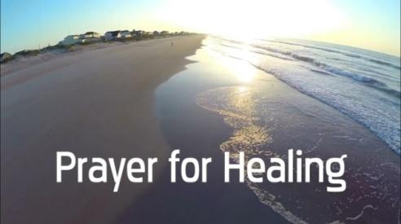

Please Pray For
CPS Preschool – Pinky Burgos – Mary and Neal Commerford
Vera Bonislawski - Linda Mitola (Linda’s mother-in-law)
Tom Grigal - Alix (Kessler) Grigal - Jasmine Pressley - Christine Orband – Nancy Rineer- George Hollings, 3rd – Janet Gallagher- Charles Gallagher- Nick and Ruth Sottos– Jimmy (Laura’s brother) - Sidney Stafford – Cindy Shilling
Elizabeth Woodruff - Mark’s wife- Bob Wands – May Kemp- Ruth Thomas
Allen Stephenson- Bonnie Berry- Al Lawrence- Roger William - Mike Woodruff
Milt Woodruff – Linda Mitola- Aidan Holmes- Frank Rebimbas

NURSING HOMES & REHABILITATION FACILITIES
Jo Fusco - Franklin Schmitz- Nelson Carle
Today’s Anthem

How Beautiful

How beautiful the hands that served the wine and the bread and the sons of the earth
How beautiful the feet that walked the long dusty roads and the hill to the cross.
How beautiful, how beautiful, how beautiful is the body of Christ
How beautiful the heart that bled, that took all my sin and bore it instead
How beautiful the tender eyes that chose to forgive and never despise
How beautiful, how beautiful, how beautiful is the body of Christ.
See from his head, his hands, his feet, sorrow and love flow mingled down.
Did e'er such love and sorrow meet, or thorns compose so rich a crown?
How beautiful the feet that bring the sound of good news and the love of the King.
How beautiful the hands that serve the wine and the bread and the sons of the earth.
How beautiful, how beautiful, how beautiful is the body of Christ.

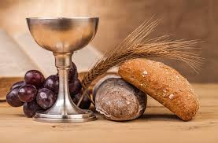
THE SACRAMENT OF HOLY COMMUNION
(Musical Setting TFWS 2257-b-c-d)

Pastor: The Lord be with you.
People: And also with you.
Pastor: Lift up your hearts.
People: We lift them up to the Lord.
Pastor: Let us give thanks to the Lord our God.
People: It is right to give our thanks and praise.

Pastor: It is right, and a good and joyful thing, always and everywhere to give thanks to you, Father Almighty, creator of heaven and earth. In love you made us for yourself; and when we had fallen into sin and become subject to evil and death, your love remained steadfast.
You bid your faithful people cleanse their hearts and prepare with joy for the Easter feast, that, renewed by your Word and Sacraments and fervent in prayer and works of justice and mercy, we may come to the fullness of grace, that you have prepared for those who love you.
And so, with your people on earth and all the company of heaven we praise your name and join
their unending hymn:

People: Holy, holy, holy Lord, God of power and might,
heaven and earth are full of your glory.
Hosanna in the highest! Hosanna in the highest! Hosanna in the highest!
Blest is the one who comes in the name of the Lord.
Hosanna in the highest! Hosanna in the highest! Hosanna in the highest!
Pastor: Holy are you, and blessed is your Son Jesus Christ, whom you sent in the fullness of time to redeem the world. He emptied himself, taking the form of a servant, being born in our likeness. He humbled himself and became obedient unto death, even death on a cross. He took upon himself our sin and death and offered himself, a perfect sacrifice for the sin of the whole world. By the baptism of his suffering, death, and resurrection you gave birth to your church, delivered us from slavery to sin and death, and made with us a new covenant by water and the Spirit.
On the night in which he gave himself up for us, he took bread, gave thanks to
you, broke the bread, gave it to his disciples, and said: "Take, eat; this is my
body which is given for you. Do this in remembrance of me."

When the supper was over, he took the cup, gave thanks to you, gave it to his
disciples, and said: "Drink from this, all of you; this is my blood of the new
covenant, poured out for you and for many for the forgiveness of sins. Do this,
as often as you drink it, in remembrance of me."

And so, in remembrance of these your mighty acts in Jesus Christ, we offer
ourselves in praise and thanksgiving as a holy and living sacrifice, in union
with Christ's offering for us, as we proclaim the mystery of faith.

People: Christ has died; Christ is risen; Christ will come again.
Hosanna in the highest! Hosanna in the highest! Hosanna in the highest!

Pastor: Pour out your Holy Spirit on us gathered here, and on these gifts of bread
and wine. Make them be for us the body and blood of Christ, that we may be
for the world the body of Christ, redeemed by his blood.

By your Spirit make us one with Christ, one with each other, and one in
ministry to all the world, until Christ comes in final victory and we feast at his
heavenly banquet.

Through your Son Jesus Christ, with the Holy Spirit in your holy Church, all
honor and glory is yours, almighty Father, now and forever.

People: Amen.

Pastor: And now, with the confidence of the children of God, let us pray:

THE LORD’S PRAYER

SHARING OF BREAD AND CUP Jeff Manno, organist

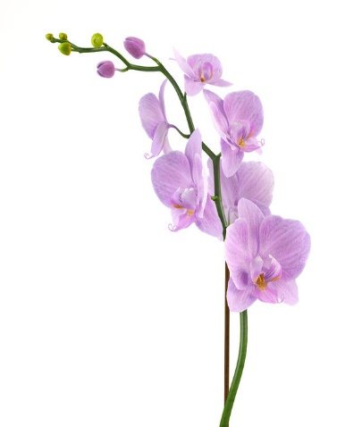
Congratulations to all
ORCHID CLUB MEMBERS 2024

We honor those worshipping with us today:

Edith Hartmann
David Kessler
Mary Meglio
Milton Woodruff

We keep in our prayers those who are not able to be with us in person today:

Nelson Carle
Jo Fusco
George Hollings, III
Charles Lawrence
Priscilla Lawrence
Franklin Schmitz
Nicholas Sottos
Ruth Sottos

