COMMUNITY UNITED METHODIST CHURCH
301 CHESTNUT STREET – ROSELLE PARK, NJ 07204
OFFICE: (908) 245-2237+1
- - - - - - - - - - - - - - - - - - - - - - - - - - - - - - - - - - - - - - - - - - -
Rev. Jisu Ahn
PASTOR’S CELL NUMBER: (862) 217-9499
OFFICE HOURS TUES- FRI 10-2PM
* * *
November 9, 2025

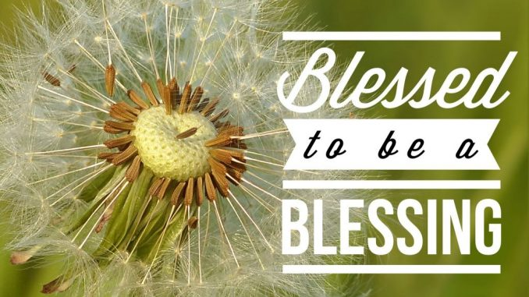

Mission Statement
The Mission of Community United Methodist Church is to be a witness of Jesus Christ for the common good of all peoples by providing Hope and Love to everyone.

Vision Statement
Community United Methodist Church is a place where everyone is welcome to come together to experience and share God’s presence in accepting, caring, nurturing, witnessing, and serving one another and the entire community
November 9, 2025 TWENTY- SECOND SUNDAY AFTER PENTECOST 11:00 AM

~ ~ ~ ~ ~ ~ ~ ~ ~ ~ ~ ~ ~ ~ ~ ~ ~ ~ ~ ~ ~ ~ ~ ~ ~ ~ ~ ~ ~ ~ ~ ~ ~ ~ ~ ~ ~ ~ ~ ~ ~ ~ ~ ~ ~ ~ ~ ~ ~ ~ ~ ~ ~ ~ ~ ~ ~
*Please Stand (If you are able)
GATHERING IN GOD’S PRESENCE

PRELUDE Jeff Manno Organist

WELCOME, GREETINGS AND ANNOUNCEMENTS

SILENT PRAISE AND REFLECTION

PRAISE TEAM “Would I Have Answered When You Called” TFWS #2137

* CALL TO WORSHIP
Liturgist: God calls us to go where He leads,
People: and promises to bless us on the journey.
Liturgist: In faith, we follow the voice of grace.
People: In gratitude, we receive the blessings of God.
Liturgist: Let us worship the One who calls and blesses His people.
People: We come to praise the Lord of every blessing!
*GATHERING HYMN “Come, Thou Fount of Every Blessing” UMH #400

OPENING PRAYER
Gracious God, You call us by name and bless us beyond measure. Open our hearts today to recognize every gift that comes from You. Teach us to receive Your grace with gratitude and to walk in faith wherever You lead. Amen.

PASSING OF PEACE

JOYFUL NOISE COLLECTION Bridges Lunches

CHOIR ANTHEM “Lautemus Te” Sanctuary Choir

PROCLAIMING THE WORD OF GOD

READING OF THE SCRIPTURE LESSONS
Scripture Reading Genesis 12:1–9 Dennis Berry

HYMN "Be Thou My Vision” UMH # 451

MEDITATION Blessed to Be a Blessing Week 1 – Receiving the Blessing
“Called by Grace to Become a Blessing” Pastor Jisu Ahn

OFFERTORY

OFFERTORY HYMN “Give Thanks” TFWS #2036

DEDICATION OF THE OFFERING
Generous God, You are the source of every blessing. We bring these gifts as signs of our gratitude, trusting that You will use them to bless others as You have blessed us. In Jesus’ name, Amen.

THE OFFERING OF JOYS AND CONCERNS

PASTORAL PRAYER

THE LORD’S PRAYER

GOING FORTH TO SERVE AS THE PEOPLE OF GOD

*CLOSING HYMN “O Jesus, I Have Promised” UMH #396

*BLESSING

RESPONSE “Here I Am, Lord” UMH # 593

POSTLUDE Jeff Manno, Organist

CARRYING CHRIST'S LIGHT INTO THE WORLD
Worshiping God as a “gathered church” has ended, but our life and witness, as a “dispersed church” is about to begin. The light of Christ received today, is the light we bring with us to the world

LECTIONARY READING FOR TODAY
Old Testament: Genesis 12: 1-9
Psalm: Psalm 145: 1-5, 17-21
New Testament: 2 Thessalonians 2: 1-5, 13-17
Gospel: Luke 20: 27-38
~ ~ ~ ~ ~ ~ ~ ~ ~ ~ ~ ~ ~ ~ ~ ~ ~ ~ ~ ~ ~ ~ ~ ~ ~ ~ ~ ~ ~ ~ ~ ~ ~ ~ ~ ~ ~ ~ ~ ~ ~ ~ ~ ~ ~ ~ ~ ~ ~ ~

CUMC Website: roselleparkcumc.org E-mail: cumcrosellepark@gmail.com
COMMUNITY PRESCHOOL Phone: (908) 245-8651 Website: www.rpcommunitypreschool.com

CUMC Upcoming Activities and Events
Save the Date!

Wed Nov 12 Wed night gathering – Bible Study 7:00PM RH
Thurs Nov 13 Council Meeting 7:00PM RH
Sun Nov 16 Worship Service 11:00AM Sanctuary
Wed Nov 19 Wed night gathering – Bible Study 7:00PM RH
Sun Nov 23 Worship Service 11:00AM Sanctuary
Sun Nov 30 Worship Service 11:00AM Sanctuary

We appreciate your pledges. Due to new banking policies, kindly made checks payable to Community United Methodist Church. Thank you.


In our prayers this week:

Wands Family Pinky Burgos Linda Demas Martha Farris
Janet Gallagher Alix (Kessler) Grigal Tommy Grigal Elka Harms John Karathanos Linda Mitola Bob Morgan Donna Petrosky Barbara Powers Nancy Rineer Cindy Shilling Father John Spino Nick and Ruth Sottos
Stephenson Family Ruth Thomas Linda Trout Evonne Tyree Carol Wilson Family of Helen Holliday Roger William Elizabeth Woodruff Milt Woodruff
- All those dealing with Mental Health Issues
- Victims Worldwide of Natural Disasters

NURSING HOMES & REHABILITATION FACILITIES
Mary and Neal Commerford



11/16 Jeff Manno

November Sermon Series: “Blessed to Be a Blessing”
God blesses us so that His blessing may flow through us to others.
- Nov 9 – Week 1: Receiving the Blessing
“Called by Grace to Become a Blessing” – Genesis 12:1–9

- Nov 16 (Stewardship Sunday) – Week 2: Sharing the Blessing
“Giving Freely from What We Have Received” – 2 Corinthians 9:6–15

- Nov 23 (Thanksgiving Sunday) – Week 3: Returning in Thanksgiving
“Blessing the Giver with a Grateful Heart” – Colossians 3:15–17

