COMMUNITY UNITED METHODIST CHURCH
301 CHESTNUT STREET – ROSELLE PARK, NJ 07204
OFFICE: (908) 245-2237+1
- - - - - - - - - - - - - - - - - - - - - - - - - - - - - - - - - - - - - - - - - - -
Rev. Jisu Ahn
PASTOR’S CELL NUMBER: (862) 217-9499
OFFICE HOURS TUES- FRI 10-4PM
* * *
April 21, 2024

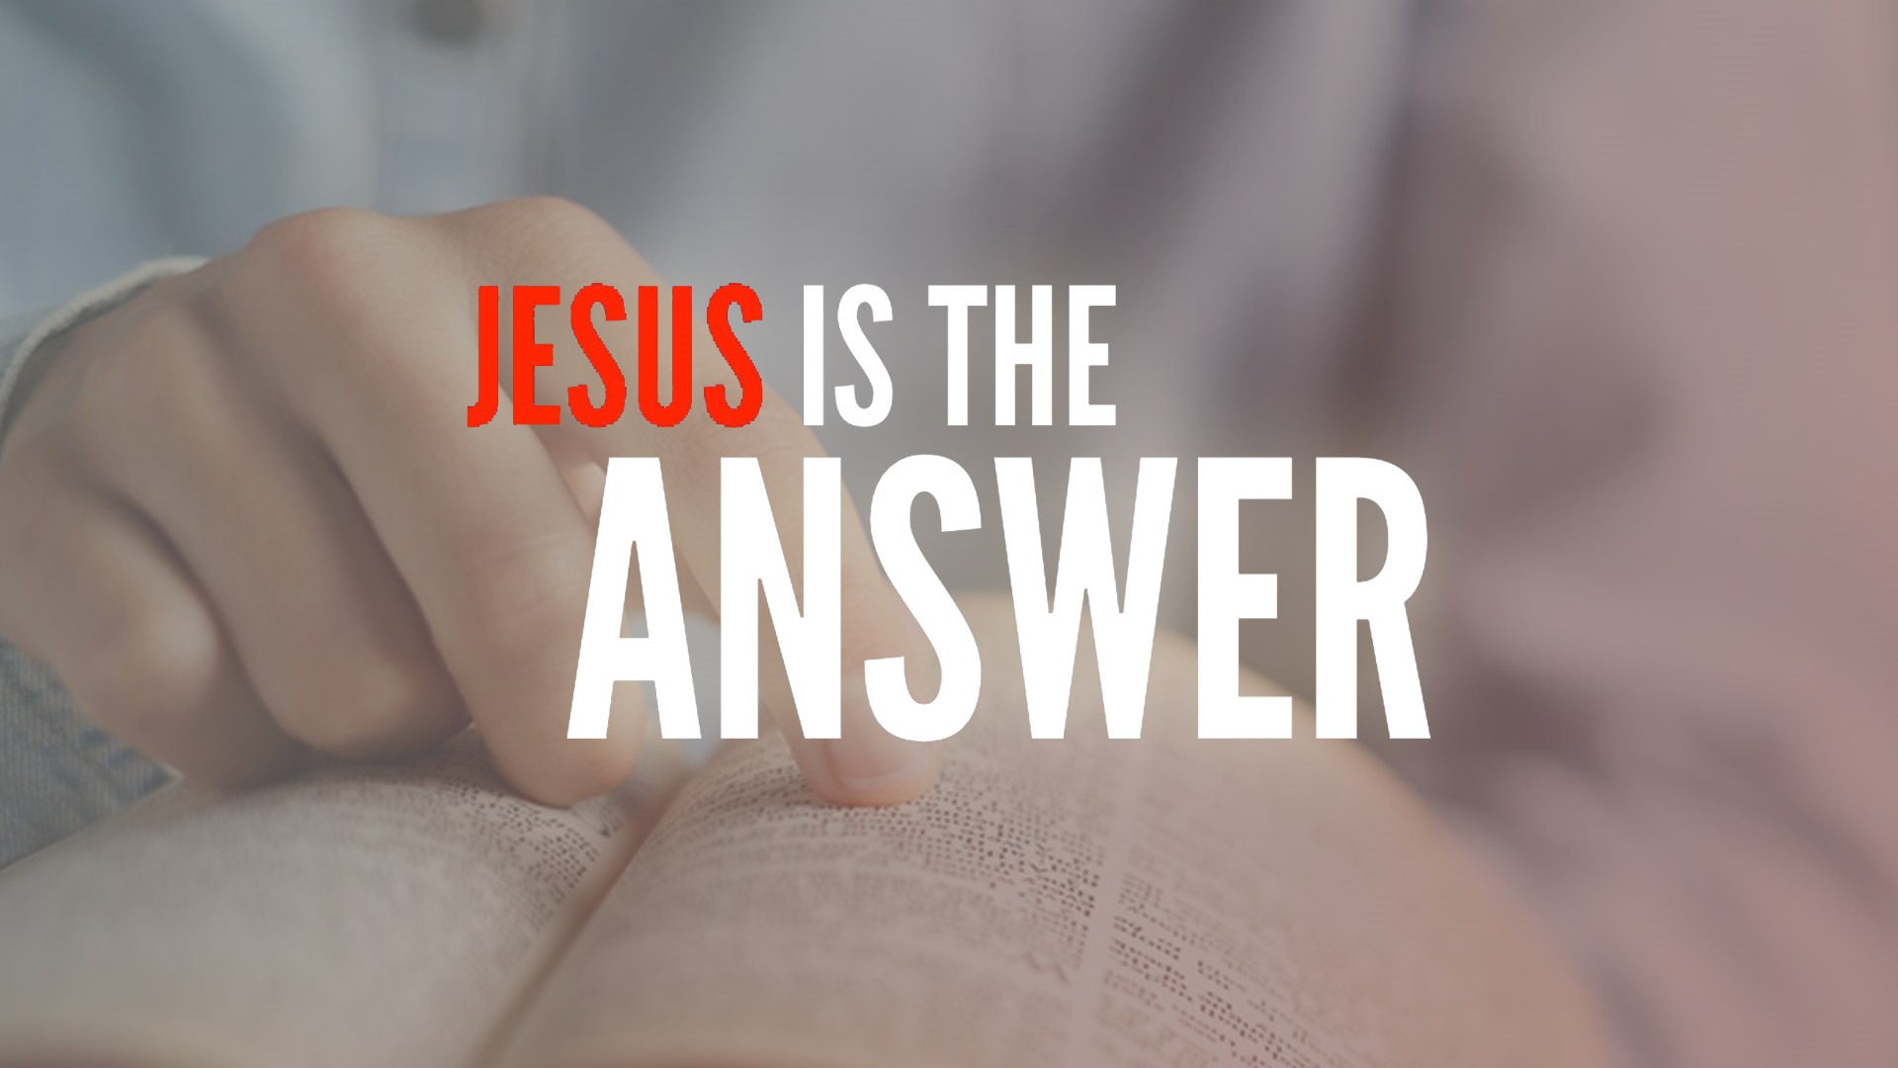

Mission Statement
The Mission of Community United Methodist Church is to be a witness of Jesus Christ for the common good of all peoples by providing Hope and Love to everyone.

Vision Statement
Community United Methodist Church is a place where everyone is welcome to come together to experience and share God’s presence in accepting, caring, nurturing, witnessing, and serving one another and the entire community
April 21, 2024 FOURTH SUNDAY OF EASTER 11:00AM
~ ~ ~ ~ ~ ~ ~ ~ ~ ~ ~ ~ ~ ~ ~ ~ ~ ~ ~ ~ ~ ~ ~ ~ ~ ~ ~ ~ ~ ~ ~ ~ ~ ~ ~ ~ ~ ~ ~ ~ ~ ~ ~ ~ ~ ~ ~ ~ ~ ~ ~ ~ ~ ~ ~ ~ ~ ~
*Please Stand If you are able UMH – United Methodist Hymnal TFWS – The Faith We Sing

GATHERING IN GOD’S PRESENCE

PRELUDE Jeff Manno, organist

WELCOME, GREETINGS AND ANNOUNCEMENTS

SILENT PRAISE AND REFLECTION

PRAISE TEAM “I Am Your Mother” TFWS 2059

* CALL TO WORSHIP
Liturgist: "Be still, and know that I am God; I will be exalted among the nations, I will be exalted in the earth!"
All: In this world of noise and chaos, we find peace in your presence, O God. Let us worship!

*GATHERING HYMN “Great Is Thy Faithfulness” UMH 140

OPENING PRAYER
Creator God, we come together today, grateful for the gift of this new day. Open our minds to your wisdom and guide our steps as we journey together. Fill us with your love and may this time of worship bring us closer to you and to one another. Amen.

PASSING OF PEACE

JOYFUL NOISE COLLECTION Bridges Lunches

CHOIR ANTHEM “Soon and Very Soon” Sanctuary Choir

PROCLAIMING THE WORD OF GOD

READING OF THE SCRIPTURE LESSONS
Scripture Reading: Acts 4:5-12 Pastor

HYMN “God Of Grace And God Of Glory” UMH 577

MEDITATION “Jesus Is The Answer” Pastor Jisu Ahn

OFFERTORY

OFFERTORY HYMN “Give Thanks” TFWS 2036

DEDICATION OF THE OFFERING
As we offer our tithes and offerings, we are reminded of the importance of generosity and stewardship in every aspect of our lives. May these gifts be a reflection of the love we have experienced in Christ and our commitment to steward them faithfully for the work of your kingdom.

GOING FORTH TO SERVE THE WORD OF GOD

THE OFFERING OF JOYS AND CONCERNS

PASTORAL PRAYER

THE LORD’S PRAYER

*CLOSING HYMN “O For a Thousand Tongues to Sing” UMH 57

*BLESSING

RESPONSE “Grace Alone" TFWS 2162

POSTLUDE

COFFEE FELLOWSHIP
CARRYING CHRIST'S LIGHT INTO THE WORLD
Worshiping God as a “gathered church” has ended, but our life and witness, as a “dispersed church” is about to begin. The light of Christ received today, is the light we bring with us to the world
.

~ ~ ~ ~ ~ ~ ~ ~ ~ ~ ~ ~ ~ ~ ~ ~ ~ ~ ~ ~ ~ ~ ~ ~ ~ ~ ~ ~ ~ ~ ~ ~ ~ ~ ~ ~ ~ ~ ~ ~ ~ ~ ~ ~ ~ ~ ~ ~ ~ ~ ~
LECTIONARY READINGS FOR TODAY

Old Testament: Acts 4: 5-12
Psalm Psalm 23
New Testament: 1 John 3: 16-24
Gospel: John 10: 11-18
~ ~ ~ ~ ~ ~ ~ ~ ~ ~ ~ ~ ~ ~ ~ ~ ~ ~ ~ ~ ~ ~ ~ ~ ~ ~ ~ ~ ~ ~ ~ ~ ~ ~ ~ ~ ~ ~ ~ ~ ~ ~ ~ ~ ~ ~ ~ ~ ~ ~
CUMC Website: roselleparkcumc.org E-mail: cumcrosellepark@gmail.com
COMMUNITY PRESCHOOL Phone: (908) 245-8651 Website: www.rpcommunitypreschool.com

Worship Schedule

April 28, 2024 11:00 am Worship Service

May 5, 2024 11:00 am Worship Service
ORCHID CLUB

Please Pray For
CPS Preschool – Pinky Burgos – Mary and Neal Commerford
Vera Bonislawski - Linda Mitola (Linda’s mother-in-law)
Tom Grigal - Alix (Kessler) Grigal - Jasmine Pressley - Christine Orband –
Nancy Rineer- George Hollings, 3rd – Janet Gallagher- Charles Gallagher- Nick and Ruth Sottos– Jimmy (Laura’s brother) - Sidney Stafford – Elizabeth Woodruff - Bob Wands –May Kemp- Ruth Thomas – Allen Stephenson
Al Lawrence- Roger Williams – Pobanz Family- Mike Woodruff
Milt Woodruff – Linda Mitola- Aidan Holmes- Frank Rebimbas

NURSING HOMES & REHABILITATION FACILITIES
Jo Fusco - Franklin Schmitz- Nelson Carle
Today’s Anthem

Soon and Very Soon

Soon and very soon, we are going to see the King.
Soon and very soon, we are going to see the King
Soon and very soon, we are going to see the King; Hallelujah! Hallelujah! We're going to see the King.
Soon and very soon, we are going to see the King
Soon and very soon, we are going to see the King
Soon and very soon, we are going to see the King; Hallelujah! Hallelujah! We're going to see the King.
No more dying there, we are going to see the King
No more dying there, we are going to see the King
No more dying there, we are going to see the King; Hallelujah! Hallelujah! We're going to see the King.
Soon and very soon, we are going to see the King; Hallelujah! Hallelujah! We're going to see the King.

