COMMUNITY UNITED METHODIST CHURCH
301 CHESTNUT STREET – ROSELLE PARK, NJ 07204
OFFICE: (908) 245-2237+1
- - - - - - - - - - - - - - - - - - - - - - - - - - - - - - - - - - - - - - - - - - -
Rev. Jisu Ahn
PASTOR’S CELL NUMBER: (862) 217-9499
OFFICE HOURS TUES- FRI 10-2PM
* * *
February 8, 2026

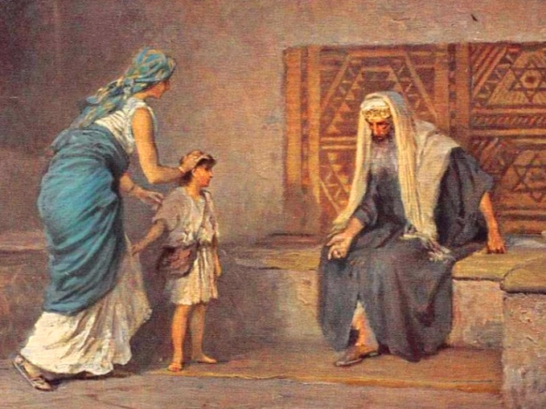

Mission Statement
The Mission of Community United Methodist Church is to be a witness of Jesus Christ for the common good of all peoples by providing Hope and Love to everyone.

Vision Statement
Community United Methodist Church is a place where everyone is welcome to come together to experience and share God’s presence in accepting, caring, nurturing, witnessing, and serving one another and the entire community
February 8, 2026 FIFTH SUNDAY AFTER THE EPIPHANY 11:00 AM

~ ~ ~ ~ ~ ~ ~ ~ ~ ~ ~ ~ ~ ~ ~ ~ ~ ~ ~ ~ ~ ~ ~ ~ ~ ~ ~ ~ ~ ~ ~ ~ ~ ~ ~ ~ ~ ~ ~ ~ ~ ~ ~ ~ ~ ~ ~ ~ ~ ~ ~ ~ ~ ~ ~ ~ ~
*Please Stand (If you are able)
GATHERING IN GOD’S PRESENCE

PRELUDE Jeff Manno Organist

WELCOME, GREETINGS AND ANNOUNCEMENTS

SILENT PRAISE AND REFLECTION

PRAISE TEAM “His Eye Is on the Sparrow” TFWS # 2146

*CALL TO WORSHIP
Liturgist: We come to worship the God who hears our prayers and remembers our cries.
All: We come with grateful hearts for all that God has given us.
Liturgist: We come trusting the God who remains faithful beyond the blessing.
All: We come ready to offer our lives back to God.
Liturgist: Let us worship with open hands and willing hearts.
All: We come to worship the Lord our God.

*GATHERING HYMN "Holy, Holy, Holy! Lord God Almighty” UMH #64

OPENING PRAYER
Gracious God, we gather today grateful for all that you have given us. Open our hearts to trust you not only in our need, but also in our blessing. Teach us to worship you with lives of faith and surrender. In Jesus’ name we pray. Amen.

PASSING OF PEACE

JOYFUL NOISE COLLECTION Souper Bowl Of Caring

CHOIR ANTHEM “Let There Be Peace On Earth” Sanctuary Choir

CHILDRENS MESSAGE Pastor Jisu Ahn

PROCLAIMING THE WORD OF GOD

READING OF THE SCRIPTURE LESSON
Scripture Reading 1 Samuel 1:19-28 Diane Wirkus

HYMN “Open Our Eyes” TFWS #2086

MEDITATION “Faith Beyond the Answer” Pastor Jisu Ahn
Hannah: From Tears to Praise (Week 3)
OFFERTORY

OFFERTORY HYMN “Give Thanks” TFWS #2036

DEDICATION OF THE OFFERING
Generous God, all that we have comes from you. Receive these gifts as signs of our gratitude and our trust in you. Use them, and use us, for your purposes in the world. In Jesus’ name. Amen.

THE OFFERING OF JOYS AND CONCERNS
PASTORAL PRAYER/LORD’S PRAYER

GOING FORTH TO SERVE THE WORD OF GOD

*CLOSING HYMN “I Surrender All” UMH #354

*BLESSING

RESPONSE “Here I Am, Lord” UMH #593

POSTLUDE Jeff Manno, Organist

CARRYING CHRIST'S LIGHT INTO THE WORLD
Worshiping God as a “gathered church” has ended, but our life and witness, as a “dispersed church” is about to begin. The light of Christ received today, is the light we bring with us to the world

~ ~ ~ ~ ~ ~ ~ ~ ~ ~ ~ ~ ~ ~ ~ ~ ~ ~ ~ ~ ~ ~ ~ ~ ~ ~ ~ ~ ~ ~ ~ ~ ~ ~ ~ ~ ~ ~ ~ ~ ~ ~ ~ ~ ~ ~ ~ ~ ~ ~

CUMC Website: roselleparkcumc.org E-mail: cumcrosellepark@gmail.com
COMMUNITY PRESCHOOL Phone: (908) 245-8651 Website: www.rpcommunitypreschool.com

CUMC Upcoming Activities and Events
Save the Date!
February 11 Wednesday Night Gathering/Bible Study 7:00PM RH
February 14 Men’s Club Sunrise Diner RP 9:15AM
February 15 Worship Service 11:00AM Sanctuary
February 18 Wednesday Night Gathering/Bible Study 7:00PM RH
February 22 Worship Service 11:00AM Sanctuary


In our prayers this week:

 Pinky Burgos Linda Demas Martha Farris Janet Gallagher
Alix (Kessler) Grigal Tommy Grigal Elka Harms Barbara Powers
Nancy Rineer Cindy Shilling Ruth Sottos Ruth Thomas Evonne Tyree Carol Wilson Roger William Elizabeth Woodruff Milt Woodruff
- Margie Depko Juanita Adames Allison Al Grossman
- All those dealing with Mental Health Issues
- Victims Worldwide of Natural Disasters

NURSING HOMES & REHABILITATION FACILITIES
Mary and Neal Commerford

**Please join us after service in Reeves Hall for our Souper Supper.



2/16 James Stafford

2/21 James Manzo, Jr.



THINK PINK!!

Loving our Neighbors

The PINK TREE is back! Throughout February, please stop by the PINK TREE in Reeves Hall to help feed our neighbors. Take a heart and make a donation to help CUMAC or Community Food Bank of New Jersey as they struggle to meet the demand of increased food insecurity.

This is the 18th year for the Pink Tree. Since 2009 we have collected $6,264.00.

Thank you for “Thinking Pink” and continuing to support our fight against hunger.

